**Kanban**

[**https://trello.com/invite/b/684b8da09b1efed87d8ffa10/ATTI2e362738c2bc40240eacbe799c327cbcCBF28065/tic**](https://trello.com/invite/b/684b8da09b1efed87d8ffa10/ATTI2e362738c2bc40240eacbe799c327cbcCBF28065/tic)

[**https://trello.com/b/JFoK8xsY**](https://trello.com/b/JFoK8xsY)

**Enlace de trello**

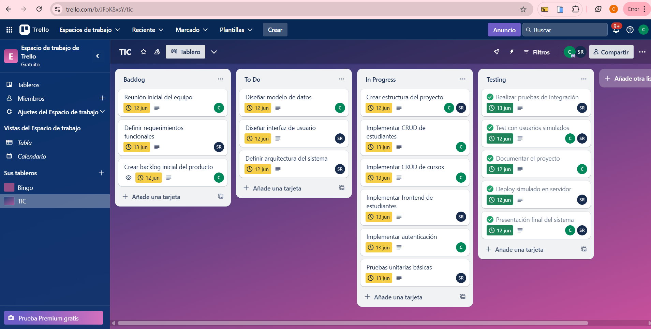

**Git**

